1. Watch the video and write down notes

Done

1. Execute all the commands shown in video.
   1. Creating .git directory
   2. Checking status

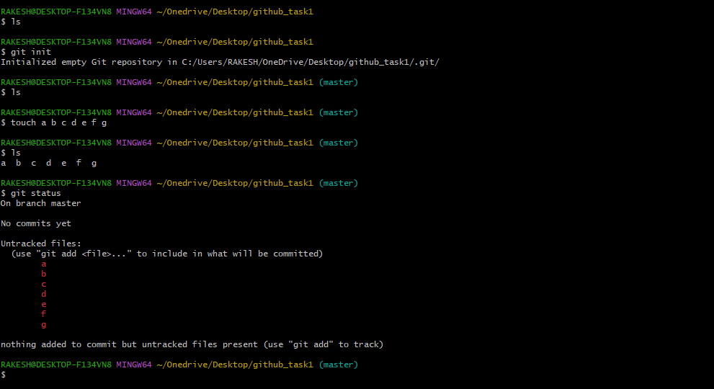

* 1. Cd .git

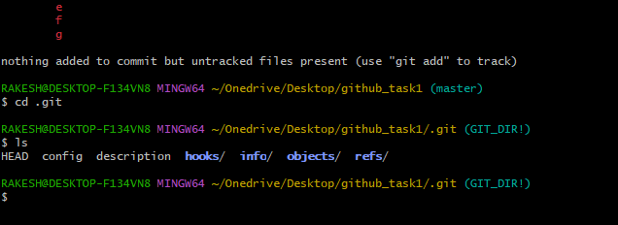

* 1. Git add .

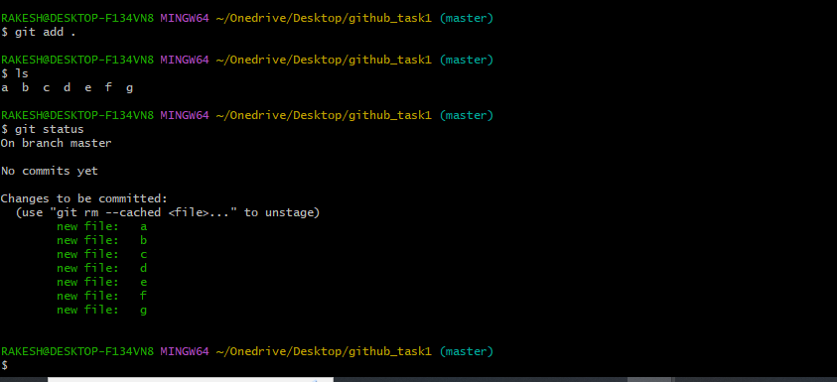

* 1. Adding user name and email using config

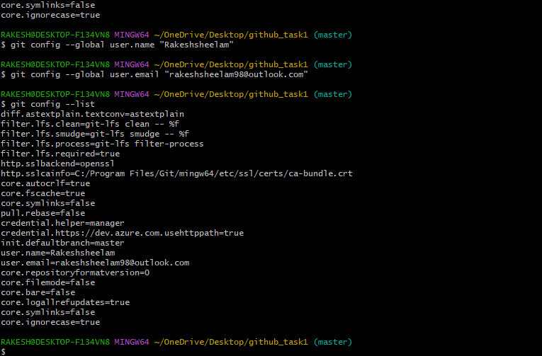

* 1. Commit the files and added comment

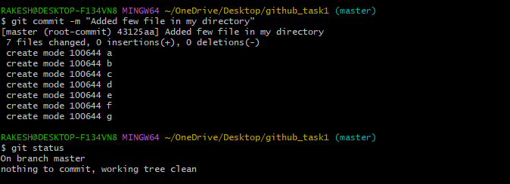

* 1. Added my github to git using ssh url

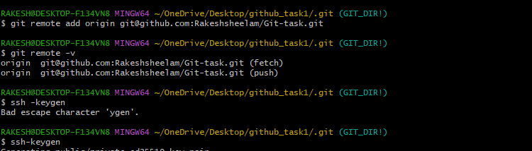

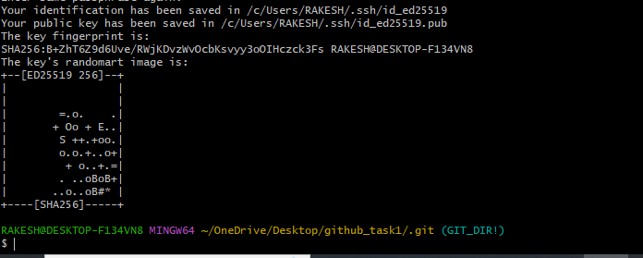

* 1. Added Public key to ssh in Github and pushed the file to Github.

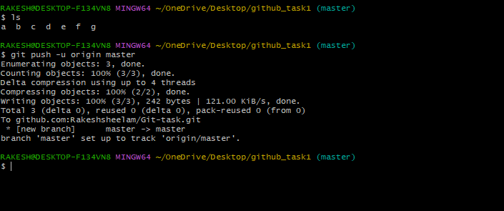

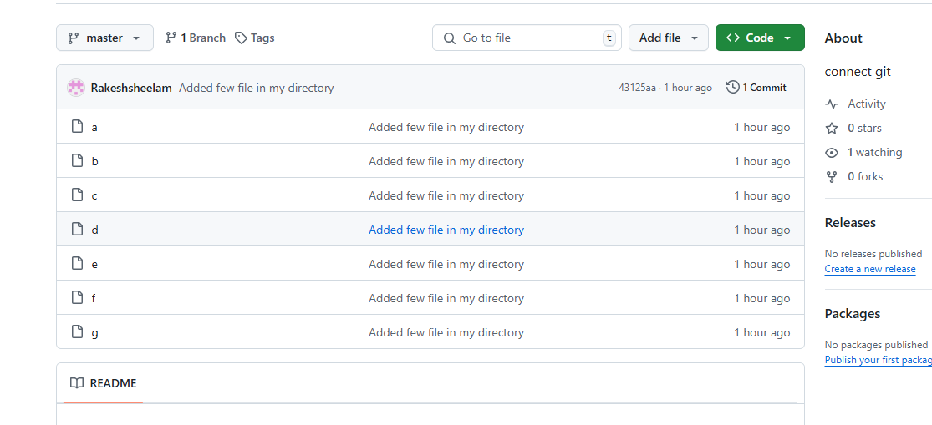

* 1. Git Pull from repository

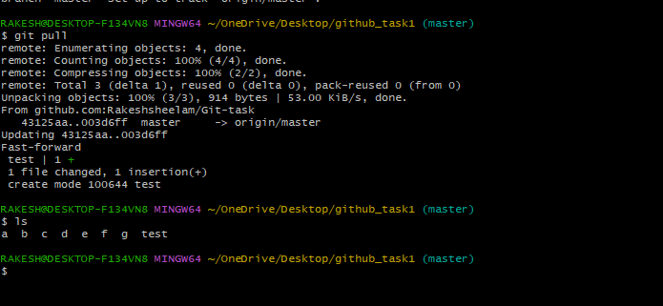

* 1. Check log

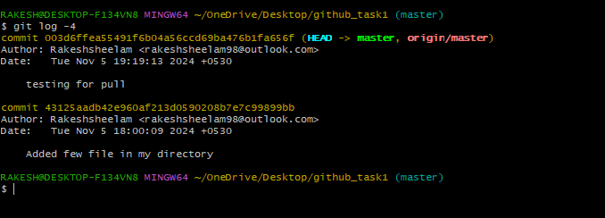

* 1. Reverting file

